BATCH ID: B5-5M1E

ROLL NO: CITC1904071

NAME: BALA DHARANI S

CODE:

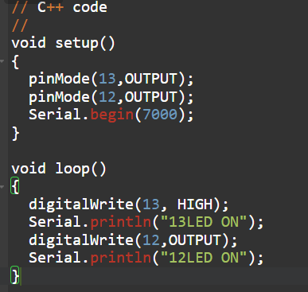

SIMULATION:

